March 10, 2026
To our Friends, Families and Supporters of Trinity Campus:
Save the date! Trinity will be hosting our 31st annual Golf Classic on Monday, June 8th, 2025, which for the first time, will be held at Valleywood Golf Course in Apple Valley! We were blessed to be able to host our event in Farmington at Fountain Valley Golf Course for many years. This past year, Bryce and Carol sold the golf course and have officially retired.
The Trinity Golf Classic is our major, annual fundraising event. This year we will be utilizing our funds to develop an outdoor seating and activity area for residents to enjoy.
Trinity Campus is a faith-based, non-profit healthcare organization and senior living community. We offer skilled nursing care (Trinity Care Center), assisted living and independent living apartments (Trinity Terrace), and a freestanding, specially designed home for those living with Alzheimer’s Disease and other dementia diagnoses (Trinity Suites).
If you are interested in learning more about how you can assist us with our fundraising, or would like to be a part of our Trinity Classic Golf Committee, please contact Joy Lauterbach (Joy.Lauterbach@sfhs.org - 651-460-1166) for more information.
Thank you for your continued support of the Trinity Golf Classic event and enriching the lives of the residents who benefit from your support!

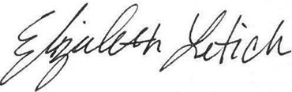
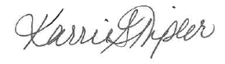
With gratitude,

Karrie Tipler Liz Letich
Administrator Regional Director
Email: Karrie.Tipler@sfhs.org Email: Elizabeth.Letich@sfhs.org
651.460.1138

Send registration form to the address below, or register Online
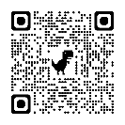
https://info.sfhs.org/trinity-golf-classic-online-registration-form/
Golf Classic Registration
Trinity Campus
905 Elm Street
Farmington MN 55024

